**Tapered cantilever beam example**

**Material Properties:**

Young’s Modulus E: 2.0340e11

Shear Modulus G: 7.8835e10

Density: 7850

**Geometry:**

Tapered square cross section: t1 = 0.1, t2 = 0.02

Length: l = 25

t1

t2

P

Fig.1 Problem definition

**FEA Model:**

Boundary condition: clamped at left end

Loading condition: Tip load at right end P =1

**Convergence Study**

|  |  |  |
| --- | --- | --- |
| # of element | Tip Deflection | Difference |
| 5 | 0.01601 |  |
| 6 | 0.01579 | 1.386% |
| 7 | 0.01566 | 0.836% |
| 8 | 0.01558 | 0.524% |

After running the convergence study, 8 elements are chosen for the FEA model since the change of tip deflection is very small.

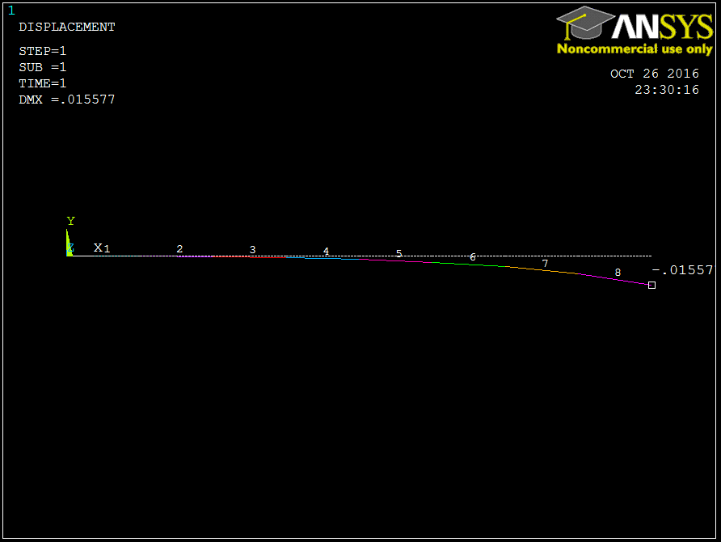

Fig. 1 Deformed shape and tip deflection

**WFEM Results:**

Tip Deflection: 0.0147

Table. 1. Results comparison

|  |  |
| --- | --- |
|  | Tip Deflection |
| ANSYS | 0.01558 |
| WFEM | 0.0147 |
| Difference | 5.63% |